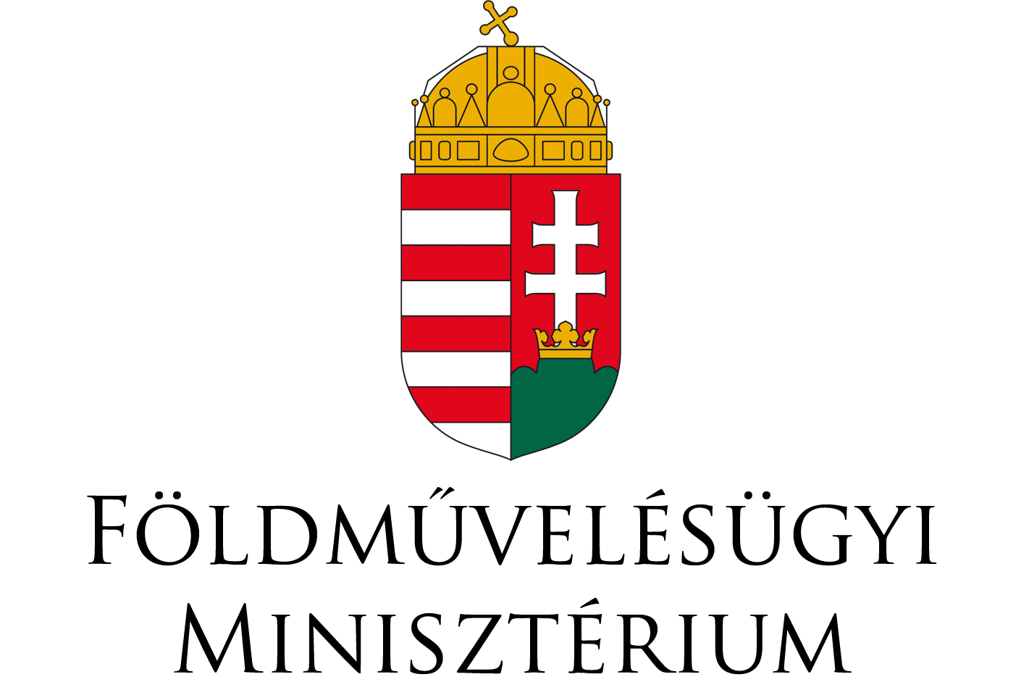 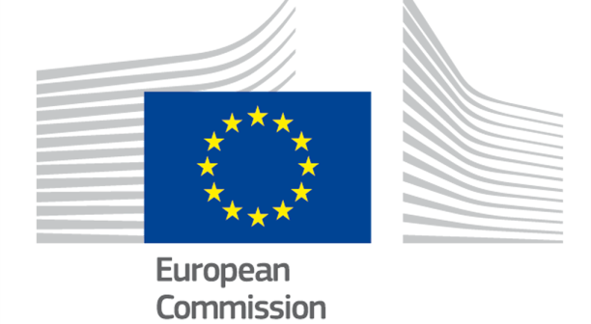

**8 November 2017**

**Conclusions of the Clean Air Dialogue between Hungary and the European Commission, taking place in Budapest on 3-4 October 2017.**

The emission of several air pollutants has decreased significantly since 1990 in Hungary; however, air pollution continues to give cause for concern and has a significant health impact. For 2014 the European Environment Agency estimated that almost 12,000 premature deaths in Hungary were attributable to fine particulate matter[1]. In addition, estimates indicate that air pollution has health-related costs in Hungary of above € 5 billion per year, including the loss of 3 million workdays per year[2].

Commitment to clean air policy is therefore important and necessary, and will also contribute to the European Union's objectives to achieve levels of air quality that do not give rise to significant negative impacts on, and risk to, human health and the environment[3]; and specifically that outdoor air quality in the Union will move closer to levels recommended by the World Health Organization.

This Clean Air Dialogue has proven valuable in promoting a more detailed understanding of the approach to clean air policy in Hungary, through the elaboration of specific national policies and measures implemented. The Dialogue facilitated an informal and open exchange of views with relevant ministries, local authorities and stakeholders, on the successes and future challenges facing clean air policy in Hungary and the inter-linkages with policies on agriculture, industry, transport, energy and climate change. It also provided insights on options for enhancing the efforts in Hungary based on wider experiences, including from other Member States, which can be facilitated notably by the Peer-to-Peer tool under the Environment Implementation Review of the European Commission. The Dialogue was also an opportunity to designate starting blocks for the new National Air Pollution Control Programme under the NEC directive. The Clean Air Dialogue with Hungary concludes that:

1. **Emissions from residential solid fuel combustion**

Annual emissions of particles from residential solid fuel combustion are increasing as well as projected emissions. This is also reflected in the reported exceedances of EU air quality limit values for particles as well as target values for BaP in ambient air.

Based on a solid inventory and projection of particle emissions from the sector, there is an urgent need for planning further actions that can reduce the emissions. The challenges to meet the reduction commitments in 2020 and 2030 in accordance with the NEC Directive will require that actions at many levels are being analysed – and decided as appropriate - such as:

* Requirements on the quality of fuels used in households and related market surveillance.
* Incentives to accelerate scrapping of sub-standard solid fuel stoves and boilers.
* Incentives to promote systematic transfer to cleaner heating sources.
* Raising public awareness on health impact of residential solid fuel combustion and operation techniques in private households, building upon the "Heat Wise" campaign and also on existing public activities relating to energy saving and efficiency.
* Enforcement of the ban on waste burning in private households.

Reducing air pollution from the residential sector is very closely connected to policies on renovation of buildings and energy installations, promotion of renewable energy, climate change and the transition to a low-carbon economy, and eradication of energy poverty. It would therefore be relevant for Hungary to further incorporate air quality efforts in other relevant policies, to utilise synergies and co-benefits as drivers for enhanced action.

The development of a National Air Pollution Control Programme by April 2019 as required by the NEC Directive will be a relevant milestone for Hungary to set coordinated directions for policies and actions on air quality, renewable energy and energy renovation.

EU funding e.g. through the Structural Funds, the European Fund for Strategic Investments and the LIFE programme, is available to support Hungary's efforts, and relevant experience from other Member States can also be drawn upon.

1. **Emissions from agriculture**

Agricultural production in Hungary is expanding which might challenge the reduction path for ammonia and will need close attention.

It is relevant for Hungary to promote measures that reduces ammonia emissions, as for example the use of near-ground spreading techniques, in order to secure the necessary results and improvements. Ammonia reductions need to be factored into further development plans and projections, also bearing in mind that the implementation of such measures could also generate economic benefits for the farmers, beyond health and environmental ones.

Vast experiences are available from other Member States on regulations and mitigation techniques that would the useful for Hungary to consider and take inspiration from. The Peer-to-Peer tool of the European Commission is available to support the transfer of experiences between Member States by the direct involvement of experts from Member States, and Hungary is encouraged to make use of it.

Reduction of ammonia is closely linked with efforts to reduce greenhouse gases and nitrates from the agricultural sector. Synergies and co-benefits should therefore as far as possible be promoted, also having in mind that measures reducing nitrogen to the air can in some cases result in increased nitrogen to the aquatic environment and vice-versa, which should be avoided.

Existing funding under the Rural Development Programme is available to support measures that directly or indirectly reduce ammonia. Pursuing co-benefits between competitiveness enhancement, technological development and environmental protection is possible in manure management including spreading and animal husbandry technologies funded by the Programme.

The first National Air Pollution Control Programme will be an opportunity to demonstrate the capability to combine growth and expansion of the agriculture sector with a cost effective pathway for reducing ammonia emissions.

1. **Emissions from industry**

Regulations of emission of air pollutants from industry, including through the use of BAT conclusions, require a close cooperation between the ministries and the industry, to ensure transparency and predictability for the investment needed. Early and continuous involvement by industry in future BAT revision work is further encouraged.

Close cooperation with climate change and energy policies is important to ensure that the policies are aligned, so that the cost of implementing BAT requirements will be a cost-effective as possible.

1. **Emissions from transport**

Whereas there is already a strong focus in Hungary on clean public transportation, e‑mobility and sustainable urban mobility planning, there is also a need for short term measures to reduce emissions from existing vehicles in the urban areas.

EU air quality limit values are reported exceeded for PM10, PM2.5 and for NO2, posing a threat to public health in urban areas. It is relevant for Hungary and its major cities to accelerate the efforts to reduce emissions from the current and future fleet of cars.

A mixture of policies utilised by other Member States including neighbouring countries should be considered in Hungary, looking for example at low emission zones or other kinds of access restrictions for transport to the major cities, fiscal incentives to promote cleaner cars and the modernisation of the current fleet, such as vehicle and fuel taxation and incentives, schemes supporting retrofitting of diesel particulate filters and SCR, calling attention of public to ensure proper technical condition of their own vehicles, incentive for promoting public transportation and non-motorized transport opportunities.

Often measures on greenhouse gas emissions, urban mobility and congestion management (e.g. charges) will also reduce air pollution. It is therefore relevant to use policies in these areas also as drivers also for air quality improvements. Pursuing such synergies will also enhance the uptake of available national and EU funding for reduction of air pollution from transport. Active involvement of Hungarian authorities in established city and local government networks can also further contribute to emulating good practices from other Member States, regions and cities facing similar challenges to Hungary.

1. **Effective uptake of available EU funding**

The Commission encourages Hungary to make full use of the EU funding mechanisms also to support the air quality and emission reduction objectives in national Air Quality Plans and the implementation of the National Air Pollution Control Programme due by April 2019. Although the primary objectives might not be the reduction of air pollutions, the objectives of the Rural Development Programme, the Operational Programmes under the Structural Funds, the European Fund for Strategic Investments, the Connecting Europe Facility (CEF) for Transport, and more, will cover actions that also reduce air pollution. Experiences elsewhere in Europe show that the European Fund for Strategic Investments and the European Investment Bank can also fund large projects that can help reduce emissions and improve air quality, e.g. by retrofits in industry and in the housing sector.

For future use of EU funding, Hungary could consider priority axes and investment priorities that include air quality.

Funding under the LIFE programme for Integrated Projects is also possible for the development of national or regional plans, programmes and strategies.

Results from past or on-going projects under the LIFE programme and from research programmes such as FP7 and Horizon 2020 could also provide contacts throughout Europe and inspiration for concrete actions in Hungary. The Commission will refer Hungary to such projects.

1. **Good Governance**

Good governance, including stakeholder involvement, is essential to effective clean air policy formulation, so as to maximise the co-benefits of action in other areas including in transport, energy, climate change and agriculture; and to increase public acceptance of necessary transitions and trade-offs. Societal adjustments will be more effectively achieved when close coordination of policies and co-benefits is being pursued.

Early and continuous involvement of the concerned stakeholders and transparency on upcoming measures and regulations are key to ensure effective implementation of mitigation measures.

Furthermore, it is important to keep in mind that objective, comparable and reliable air quality data and information is at the heart of being able to successfully engage stakeholders, manage air quality and achieve clean air.

To deliver changes on the ground and maximise the potential of existing legislation, efforts should continue to be made to ensure effective implementation and enforcement.

1. [EEA: Air quality in Europe — 2017 report](https://www.eea.europa.eu/publications/air-quality-in-europe-2017)
2. <http://ec.europa.eu/environment/eir/country-reports/index_en.htm>
3. [7th Environment Action Programme to 2020 ’Living well, within the limits of our planet’](http://ec.europa.eu/environment/action-programme/index.htm)